“A Taste of Data path + Control Design Example: Factorial Circuit (Open Ended Lab)”



Spring 2024

CSE-308L

Digital System Design Lab

Submitted by: Naveed Ahmad Registration No.: 22PWCSE2165
Class Section: B

“I affirm that I have completed this work with integrity”

Student Signature:

Submitted to:

Engr. Shah Zada Fahim Jan
Sunday, June 1, 2025

Department of Computer Systems Engineering
University of Engineering and Technology, Peshawar

Lab Objectives

To implement a circuit that calculates factorial of a number.

Block Diagram:
The datapath for computing the factorial of an N-bit number is shown below. It operates under the control of a Finite State Machine (FSM), which generates the control signals Asel, Ale, Bsel, and Ble at appropriate times to manage the datapath operations. The FSM receives an input signal Z; when Z = 0, it indicates that the computation is complete and the result (ANSWER) can be read. The corresponding State Transition Graph (STG) is also provided in the diagram.
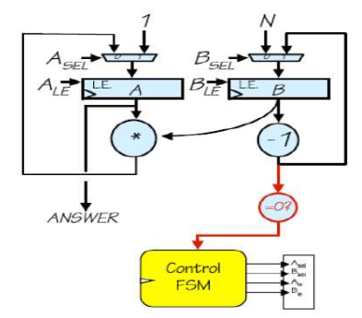

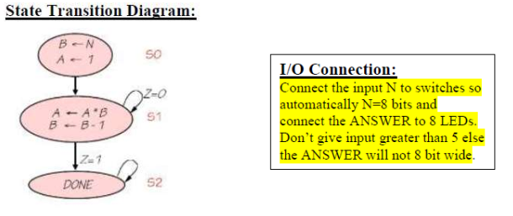

Lab Task
TASK:1
Module file:

Factorial Fsm Module:
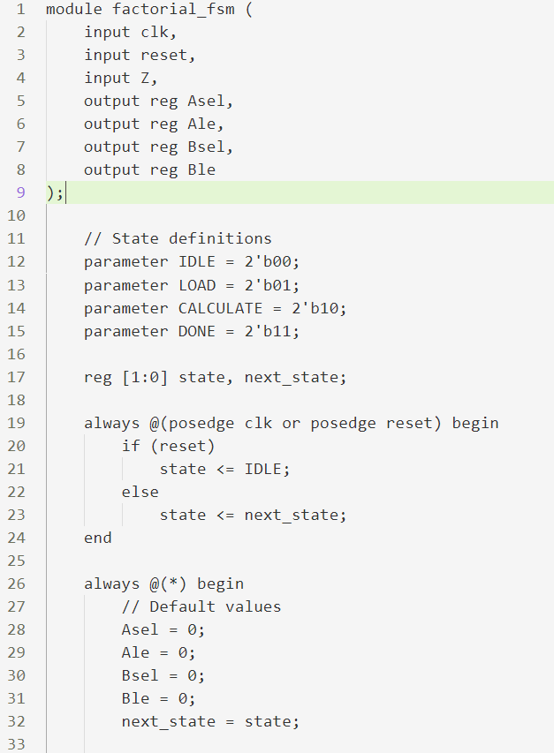
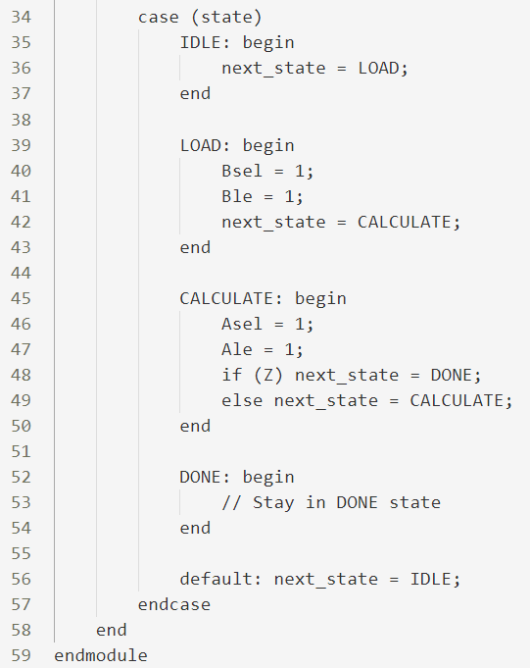
Datapath Module:

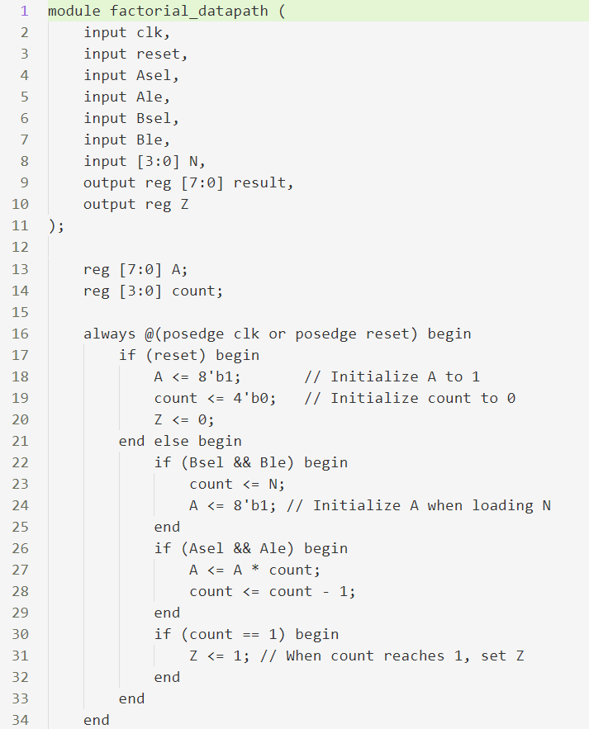

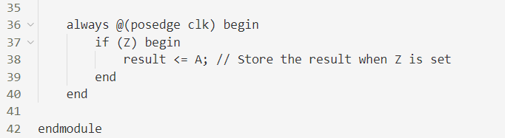

Top Module:

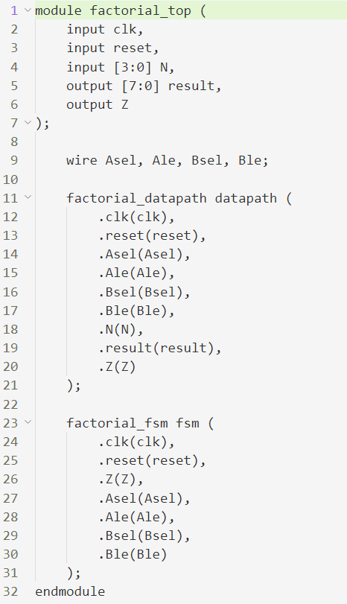

Test Bench Module:

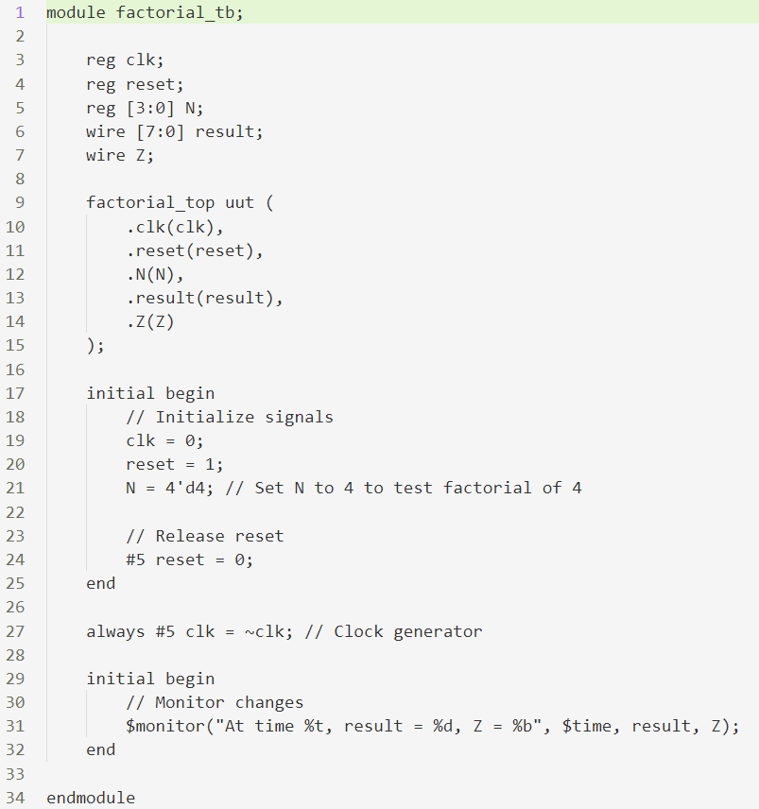

Output:

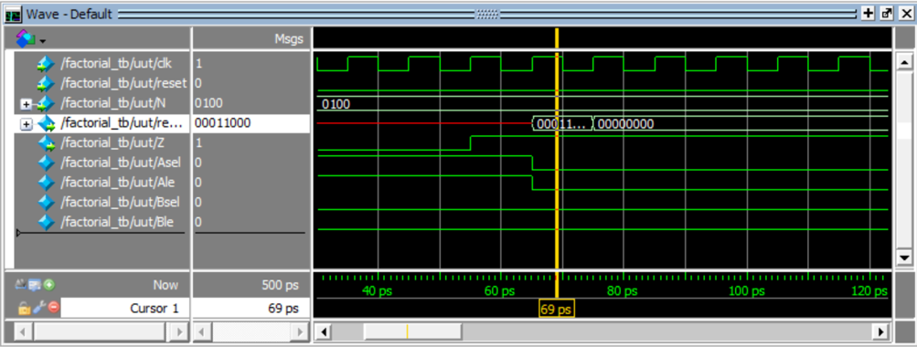

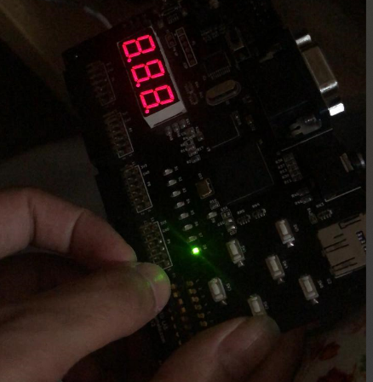
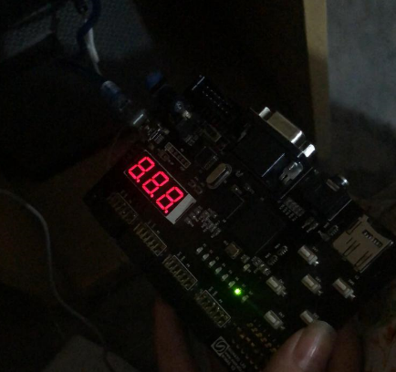
OUTPUT:

